Keswick Landing Car Show
Sunday July 19 --11am—3pm
10 Yerxa Lane
Intersection Route 104 --105
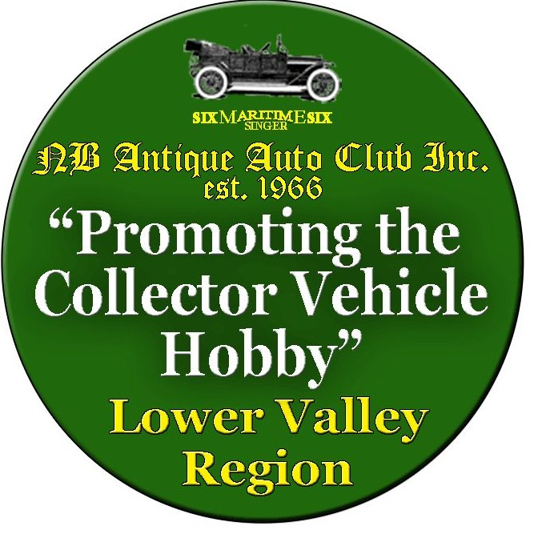
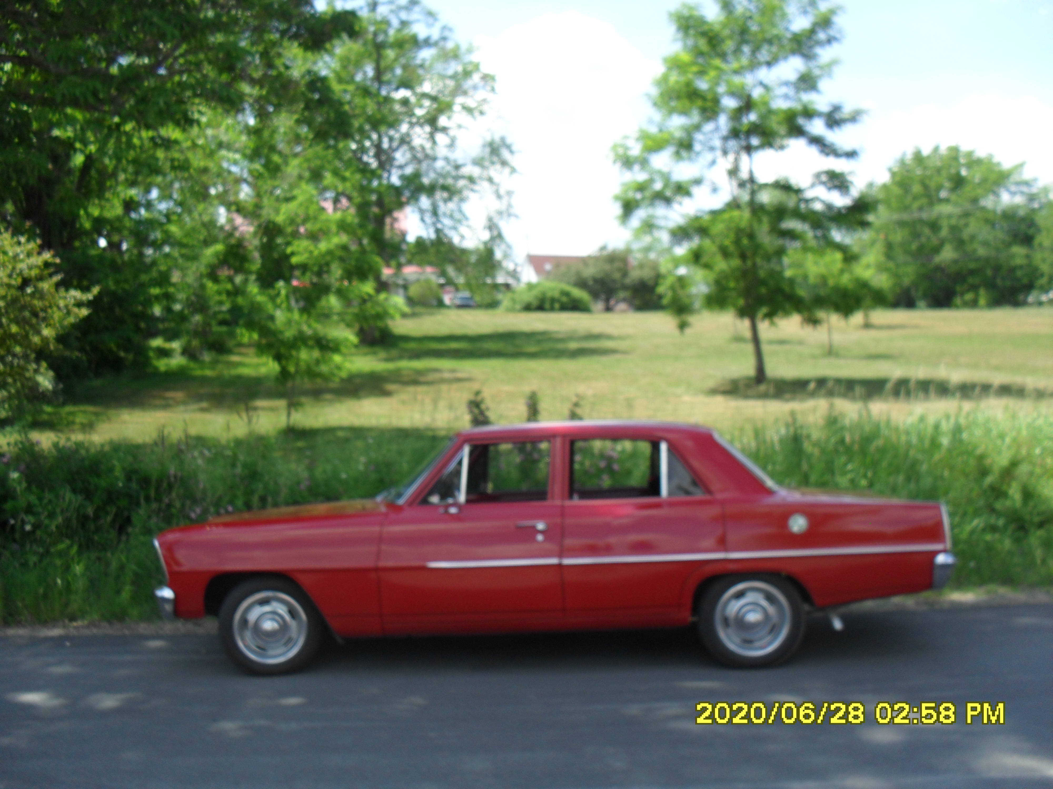
Contact Monte Merrithew @ 506-363-3936

